**Cloud Computing**

**Assignment 2b**

|  |  |  |  |
| --- | --- | --- | --- |
| Vanshika Goel | PES1UG20CS484 | Section H | Roll No 40 |

**Deliverables**

**Screenshot 1a - Minikube running successfully**

**Screenshot 2a - get nodes, pod and services command.**

**Screenshot 2b- Deployment created.**



**Screenshot 2c- get deployment and pod command .**

**Screenshot 2d- editing ‘-image:nginx.’**

**Screenshot 2e- showing edited deployment.**

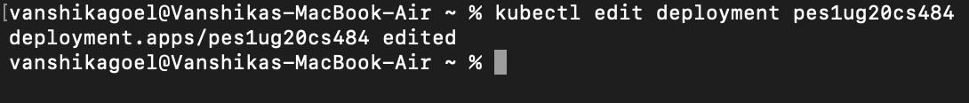

**Screenshot 2f- deployment is rolled back.**



**Screenshot 2g- showing original nginx image.**

**Screenshot 3a - Kubectl logs displayed.**

**Screenshot 3b- Kubectl ‘describe pod ‘ command.**

**Screenshot 3c - Create mongo deployment.**

**Screenshot 3d - Delete both requirements.**

**Screenshot 4a - Kubectl apply command on yaml file.**

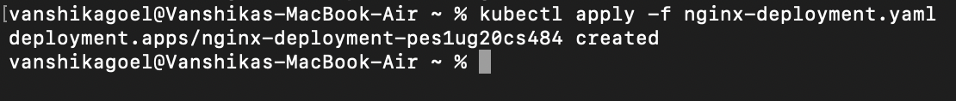

**Screenshot 4b- Kubectl get on yaml file**

**Screenshot 5a - Deleted pod**

**Screenshot 6a- Kubectl apply and get command.**

**Screenshot 6b-kubectl get pod -o wide command**

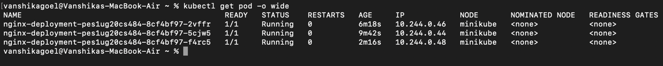

**Screenshot 7a -Kubectl port-forward command**

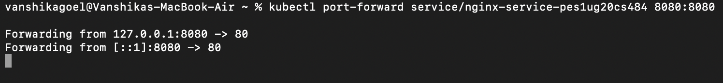

**Screenshot 7b- Display welcome to nginx on web page**

**Screenshot 8a - Delete nginx deployments**

**Screenshot 8b - stop minikube**

**Screenshot 9a- the command which exposes specifies the type of service (NodePort)**



**Screenshot 9b - kubectl get service command which displays the node port**

**Screenshot 9d - the webpage with the IP Address visible.**

